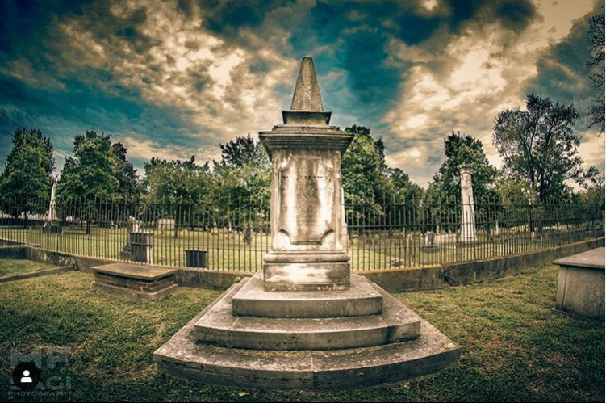

**IF TOMBSTONES COULD TALK : EPIDEMICS EDITION**

**presented by the**

**NASHVILLE CITY CEMETERY ASSOCIATION**

“More than a million people – parents, children, siblings, friends, neighbors, colleagues, teachers, classmate – all gone, suddenly, prematurely.”

* The New York Times, 2020

“The disease spread with frightful mortality, the rich and poor, the white and black...The death list one day was over 100.”

* The New York Times, 1875

**Take a tour of the Nashville oldest cemetery and explore the city’s rich history of battling disease.**

Tours are led by cemetery residents that come to life each year to tell their stories first-hand. Hear more about his fight with Cholera from former president James K. Polk.

[](https://www.facebook.com/nashcitycemetery/)[](https://www.instagram.com/nashvillecitycemetery/)

**GET TICKETS HERE**

**OR CASKET!**

**MASK IT**